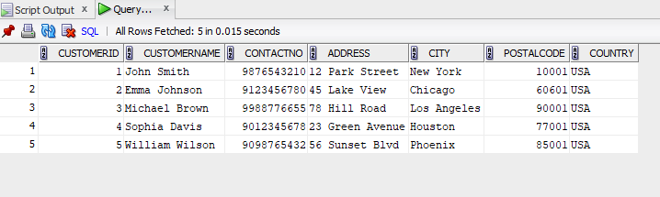

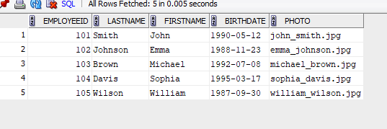

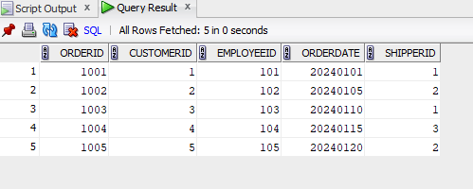

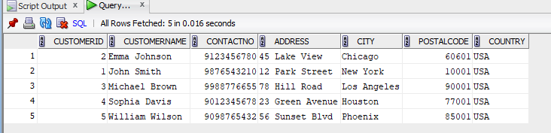

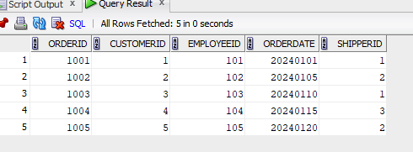

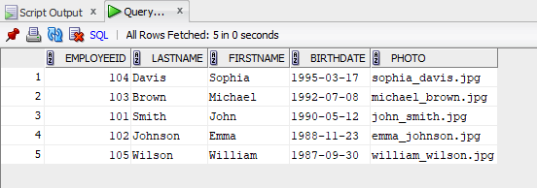

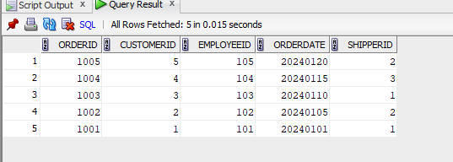

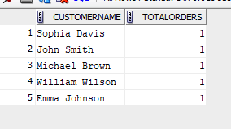

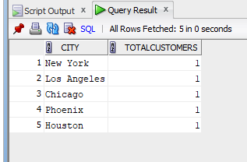

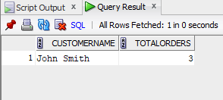
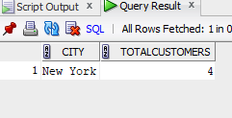

CREATE table customer_40 (CustomerID int primary key , CustomerName varchar(60), ContactNo int , Address varchar(50), City varchar(40), PostalCode int , Country varchar(60));
CREATE table Employees_40 (EmployeeID int primary key , LastName varchar(30), FirstName varchar(20) , BirthDate varchar(30), Photo varchar(30));
INSERT INTO customer_40 VALUES(1, 'John Smith', 9876543210, '12 Park Street', 'New York', 10001, 'USA');
INSERT INTO customer_40 VALUES(2, 'Emma Johnson', 9123456780, '45 Lake View', 'Chicago', 60601, 'USA');
INSERT INTO customer_40 VALUES(3, 'Michael Brown', 9988776655, '78 Hill Road', 'Los Angeles', 90001, 'USA');
INSERT INTO customer_40 VALUES(4, 'Sophia Davis', 9012345678, '23 Green Avenue', 'Houston', 77001, 'USA');
INSERT INTO customer_40 VALUES(5, 'William Wilson', 9098765432, '56 Sunset Blvd', 'Phoenix', 85001, 'USA');

INSERT INTO Employees_40 VALUES(101, 'Smith', 'John', '1990-05-12', 'john_smith.jpg');
INSERT INTO Employees_40 VALUES(102, 'Johnson', 'Emma', '1988-11-23', 'emma_johnson.jpg');
INSERT INTO Employees_40 VALUES(103, 'Brown', 'Michael', '1992-07-08', 'michael_brown.jpg');
INSERT INTO Employees_40 VALUES(104, 'Davis', 'Sophia', '1995-03-17', 'sophia_davis.jpg');
INSERT INTO Employees_40 VALUES(105, 'Wilson', 'William', '1987-09-30', 'william_wilson.jpg');

select * from customer_40 ;
select * from Employees_40;

Create table Orders_40 (OrderID int primary key , CustomerID int , EmployeeID int , OrderDate int , ShipperID int ,
foreign key(CustomerID) references customer_40(CustomerID),
foreign key(EmployeeID) references Employees_40 (EmployeeID));

INSERT INTO Orders_40 VALUES(1001, 1, 101, 20240101, 1);
INSERT INTO Orders_40 VALUES(1002, 2, 102, 20240105, 2);
INSERT INTO Orders_40 VALUES(1003, 3, 103, 20240110, 1);
INSERT INTO Orders_40 VALUES(1004, 4, 104, 20240115, 3);
INSERT INTO Orders_40 VALUES(1005, 5, 105, 20240120, 2);

select * from Orders_40 ;

SELECT * FROM customer_40 ORDER BY CustomerName ASC;

SELECT * FROM Orders_40 ORDER BY OrderDate ASC;

SELECT *
FROM Employees_40
WHERE BirthDate > '1980-12-31'
ORDER BY BirthDate DESC;

SELECT o.OrderID, o.CustomerID, o.EmployeeID, o.OrderDate, o.ShipperID
FROM Orders_40 o
JOIN customer_40 c
ON o.CustomerID = c.CustomerID
WHERE c.Country = 'USA'
ORDER BY o.OrderDate DESC;

SELECT c.CustomerName, COUNT(o.OrderID) AS TotalOrders
FROM customer_40 c
JOIN Orders_40 o
ON c.CustomerID = o.CustomerID
GROUP BY c.CustomerName;

SELECT City, COUNT(CustomerID) AS TotalCustomers
FROM customer_40
GROUP BY City;

INSERT INTO Orders_40 Values (1010, 1, 101, 20240205, 1);
INSERT INTO Orders_40 values (1011, 1, 102, 20240210, 2);

SELECT c.CustomerName, COUNT(o.OrderID) AS TotalOrders
FROM customer_40 c
JOIN Orders_40 o
ON c.CustomerID = o.CustomerID
GROUP BY c.CustomerName
HAVING COUNT(o.OrderID) > 2;

SELECT City, COUNT(CustomerID) AS TotalCustomers
FROM customer_40
GROUP BY City
HAVING COUNT(CustomerID) > 3;

INSERT INTO customer_40 VALUES(6, 'Alice Green', 9876501234, '101 Broadway', 'New York', 10001, 'USA');
INSERT INTO customer_40 VALUES(7, 'Bob White', 9876505678, '202 5th Ave', 'New York', 10001, 'USA');
INSERT INTO customer_40 VALUES(8, 'Carol Black', 9876509012, '303 Madison St', 'New York', 10001, 'USA');

SELECT City, COUNT(CustomerID) AS TotalCustomers
FROM customer_40
GROUP BY City
HAVING COUNT(CustomerID) > 3;

